**AI SRS report**

**2. Overall Description**

The product explained in this SRS document is an 8-puzzle search implementation which has a start state and a goal state. We need to reach the goal state in order to complete our search. In this we are solving our 8-Puzzle that is of 3x3 matrix. We also mention the space and time each algorithm i.e. One is an Uninformed Search (Breadth First Search), Two are part of Informed Search or Heuristic Search (Recursive Best first Search and A* Search).

**2.1. Product Perspective:**

[**N-Puzzle**](https://en.wikipedia.org/wiki/15_puzzle) or **sliding puzzle** is a popular puzzle that consists of N tiles where N can be 8, 15, 24, and so on. In our project N = 8.  The puzzle consists of N tiles and one empty space where the tiles can be moved. Start and Goal configurations (also called state) of the puzzle are provided. The puzzle can be solved by moving the tiles one by one in the single empty space and thus achieving the Goal configuration. The tiles in the initial(start) state can be moved in the empty space in a particular order and thus achieve the goal state.

Fig.2.1.1

Below is the overall structure shown of our project N-Puzzle(8-Puzzle) implementation.

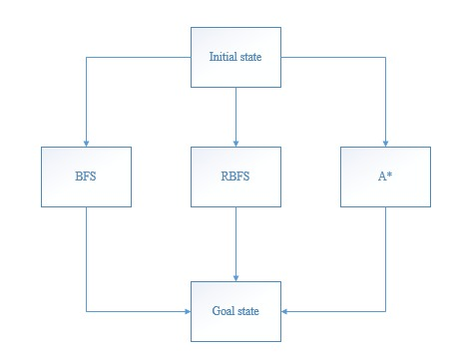

**2.2. Product Functions:**

This project aims at reaching the goal state by using various methods. We solve this puzzle in 3 different ways using 3 different algorithms which are following:

* **Breadth First Search**

Breadth-first search is the most common search strategy for traversing a tree or graph. This algorithm searches breadthwise in a tree or graph, so it is called breadth-first search. BFS algorithm starts searching from the root node of the tree and expands all successor node at the current level before moving to nodes of next level.

* **Recursive Best First Search**

Recursive Best-First Search or RBFS, is an Artificial Intelligence Algorithm that belongs to heuristic search algorithm. It expands frontier nodes in best-first order. It uses the problem specific information about the environment to determine the preference of one node over the other. RBFS is similar to a recursive implementation of depth-first search, with the difference that it uses a special condition for backtracking that ensures that nodes are expanded in best-first order.

* **A* Search**

A* Search algorithm is one of the best and popular technique used in path-finding and graph traversals. Informally speaking, A* Search algorithms, unlike other traversal techniques, it has “brains”. What it means is that it is really a smart algorithm which separates it from the other conventional algorithms.

Fig. 2.2.1

Below is the class diagram of our implementation of the code for 8-puzzle

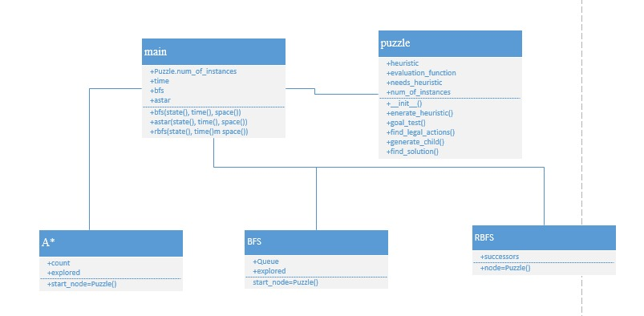

**2.3. User Classes and Characteristics:**

The possible number of moves required to reach the goal state can be more and less according t the path we decide to take. The complexity of possible moves toward the final solution in a game like this is great. It can take an average computer great length of time to find the correct sequences for a particular configuration of the 8 puzzle game if the search method is "blind". The problem is how do you make the computer order the moves intelligently to find the shortest path to the winning game state? Solving a problem such as this can be done two ways:

* Guess through every possible state by doing a blind search of the state space.
* We implement search operations that is guaranteed to find the shortest solution using an uninformed search and an informed search.

Fig.2.3.1

Below is the use case for our 8-Puzzle.

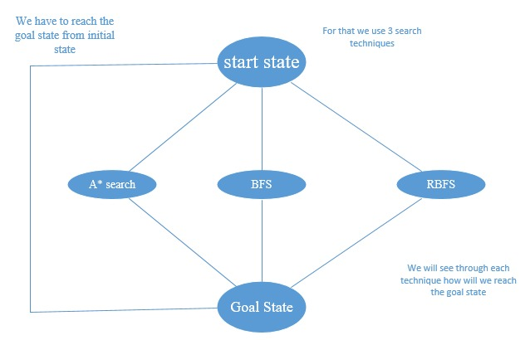

**2.4. Operating Environment:**

The language used is Python. The IDE this project is being operated on PyCharm Community Edition 2022.1. PyCharm is a cross-platform IDE that works on Windows, macOS, and Linux. PyCharm requires a Python 2.7 or Python 3.5 or newer version. PyCharm helps you

* Be more productive
* Get smart assistance
* Boost code quality

Fig.2.4.1

Below is the screenshot of our PyCharm window, the main class of our 8-Puzzle.

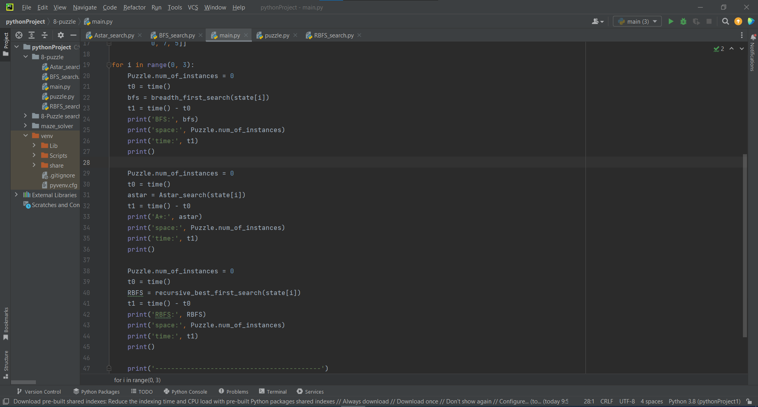

**2.5. User Documentation:**

This SRS Report is made with IEEE standard and format.